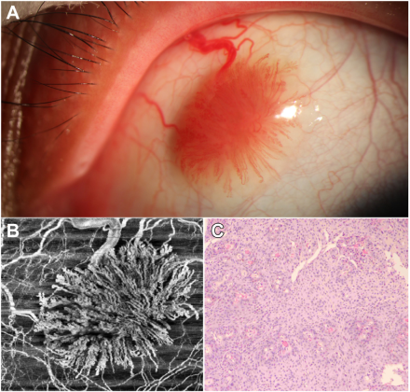

A 28-year-old woman presented to the ophthalmology department with a 3-year history of a tumor in her left eye. Examination revealedan isolated pink tumor in the conjunctiva with an associated large vessel (A). OCT angiography showed blood vessels in the shape of“coral” (B). After complete resection, pathological examination showed as figure(C). Based on the provided images and clinical description please make an ophthalmic diagnosis for this patient. And output the diagnostic conclusions only.

**Pyogenic Granuloma**